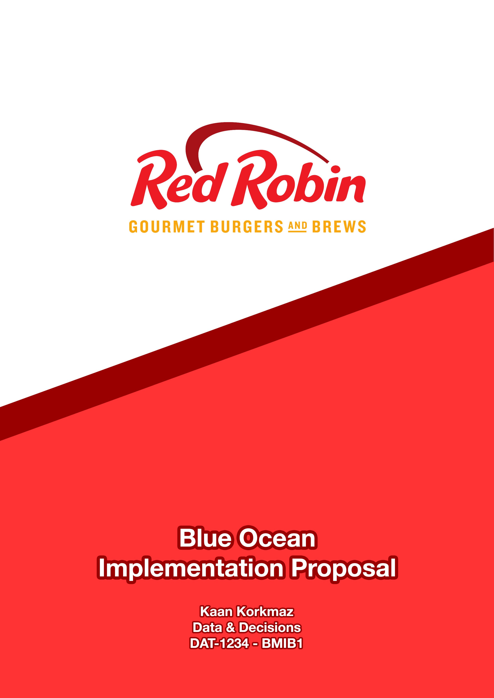

# Executive Summary

This proposal includes suggestions based on market comparison for implementing blue ocean strategy into Red Robins strategy creating more value for the brand and creating a more desirable restaurant for the customers.

Using the ERRC framework, Red Robin will eliminate unnecessary overheads, raise or reduce the operations regarding their return of customer growth rate and create new products by implementing ideas that are not used by competitors. There are nearly 50,000 burger joints across the US and competition within the industry is tough considering major players like McDonald’s and Burger King. Creating a strategy that helps them to create a unique and differentiated value proposition among competitors will open an area for Red Robin to move forward.

# Problems

There are 4 main problems with Red-Robin:

## Long Waiting Times

During peak hours of dining, customers have to wait upwards of 40 minutes for a table and their meal [1]. These waiting times cause an 85% walkaway rate and 75% of dining traffic, meaning 85% of customers don’t want to wait to prefer to choose other competitive restaurants. This also means that Red Robin can only capture 25% of potential customers [1].

## Labeled Unhealthy

Article from The Week headlined “America’s most unhealthy meal is at Red Robin”. Burgers are not categorized as healthy foods but even with burger standards, Red Robin has the image of being unhealthy with its “Monster Double Burger” menu includes 3,540 calories, which is 1.4 times the average daily calorie intake for men and 1.77 times for women [2]. With 43% of Americans looking for healthy food [3], labeled as unhealthy is not appealing for potential customers

## Fast Food Burgers Getting Better

Red Robin claims that they are the better gourmet burger than other fast-food chains that sell burgers in their restaurants. However, major competitors like McDonald’s launched ‘Signature Crafted Recipe Burgers”, and Jack in the Box’s “Rib Eyed Burger with a Red Wine Glaze” that is known to be tastier and sold at a lower price than Red Robin [4], got customer’s attention the most. Due to these competitors' promotion, they have acquired more market share. As a result, Red Robin’s market share dropped by 20% in 2017 (RR_Excel, Sheet 1).

## Poor Management Choice

In January 2018 minimum wage increased in 18 states, and Red Robin discharged busboys to compensate for this increase [5]. Although this decision saved $8 million, it meant servers would clean the tables which caused waiting time to increase even more and complaints increased with it.

A commercial about burger choices aired in 2013 and one of the choices was the new Veggie Burger. In the commercial Veggie burger announced as “Garden Burger” for “teenage girls going through a phase” [6]. Giving a burger option to vegetarians and then disrespecting their lifestyles did not go well and commercial pulled out.

# Assessment

The full-service restaurant business grew 3.2% in the last 5 years and will continue to grow by 1.8% in the next 5 years [7]. As restaurant industry sales are at $863 billion (RR_Excel, Sheet 5), competition in this red ocean with many competitors as substitutes will become zero-sum.

In this environment, because of the problems mentioned, Red Robin lost 57.4% of the stock price (RR_Excel, Sheet 1) and revenue growth are expected to continue declining. In 2019, Red Robin needs new operations to keep first-tier non-customers while capturing second and third-tier non-costumers.

Red Robin customer base is mostly

● Overage of 45 and

● Has over $80k income

● Eat at Red Robin in the afternoon or evening (RR_Excel, Sheet 4).

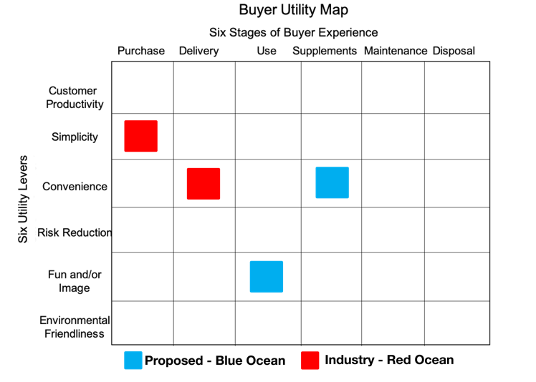In the US, 50% of burger consumption comes from ages 18-35 [8]. To reach a larger customer number, Red Robin should shift the customer age lower with lower prices.

56% of customers say they would choose a restaurant over another given the availability of discounts at off-peak times of the day (RR_Excel, Sheet 5). While Red Robin gets most of its traffic in the later of the day, it can implement discounts to increase its active hours in the day.

61% of customers say they are ordering healthier food than they did 2 years ago (RR_Excel, Sheet 5). After the “garden burger” commercial and “most unhealthy meal” article, Red Robin is neither a choice for vegetarians nor has the image of healthy food.

Red Robin launched a catering operation for parties which include making your own burger bars, savory sides, salads, desserts, and drinks. In 2018 catering sales grew to $11 million from $1 million in 2017, and prediction shows that in 2019 sales will be double [9]. This new operation proves to be profitable.

# strategic sequence

Full-serve restaurants like Red Robin are in the market of “a night out”. Restaurants not only just compete with other restaurants but also substitute evening activities like going to a movie. Hence, it is crucial for restaurants to make customers feel like it’s a special occasion.

To implement the Blue Ocean strategy Red Robin should follow the following steps in order.

### Buyer’s Utility

Red Robin should focus on the customer values that are not met by the competition. Competitors as Burger King and McDonald’s focus on the convenience of delivery and simplicity of purchase, Red Robin should focus on creating a fun environment, convenience of supplements and selections of service.

### Strategic Pricing

Red Robin is a gourmet restaurant and prices of gourmet burgers should reflect that. With off-peak hours pricing prices will be more suitable for younger customers too and for Red Robin to steal customers from fast-food restaurants with gourmet burgers at similar prices.

### Target Costing

Prices will be higher than fast-food restaurants, but the quality of ingredients will also be higher thus increasing the costs. When customer base forms and pays slightly higher prices for much better burgers, revenue will climb.

### Adaptation

Red Robin stock prices are going down and changes certainly have to be done. Proposed changes are not too radical so, stakeholders will not be affected. With changes made Red Robin will be more focused.

# Recommendations

Recommendations will follow the ERRC framework and will eliminate, reduce, raise and create.

## Eliminate deliveries

Red Robin is a gourmet restaurant with tasty burgers. When it is packaged in a container and delivered, it loses its value and becomes a standard burger from fast-food restaurants. To recreate a high-quality burger reputation, it should not deliver.

## Restaurant Overhaul (2 parts)

### Reduce People Delays

Waiting times cost %75 percent of customers to Red Robin and it is the biggest problem. Restaurants should switch to electronic tablets for orders. A waiter will take the order with the tablet and the order will be delivered to the kitchen instantly cutting serving time. With serving time decreased, the overall time spent in the restaurant will be shortened and waiting for table time will be shortened as well.

### Open-Buffet

Catering operation has grown 1100% in a year and expect to grow. On a week evening, restaurants should serve an open buffet with catering menus. This will create a special occasion for that weeknight and will be a reason for customers to dine at Red Robins that day, increase the profit for a weekday and more importantly will be a promotion for catering operation.

## Healthier Options

Red Robin is marked as unhealthy and should overcome this label. It should use locally grown and healthier ingredients in their burgers, which will incidentally taste better, and have other menu choices like salads or vegan burgers and environmentally commercialize them.

# Implementation Plan

Trial: Red Robin should try these recommendations in high-income neighborhoods first to see the reaction from customers. After 6 months of the initial trial, customer surveys should be made to understand customer needs.

Rollout: After surveys, potential problems should be addressed and improvements should start at remaining Red Robin Restaurants,

# Bibliography

|  |  |
| --- | --- |
| [1] | D. Klein, "FSR Magazine," August 2018. [Online]. Available: https://www.fsrmagazine.com/chain-restaurants/wait-times-slam-red-robins-performance. |
| [2] | "What should my daily intake of calories be?," NHS UK, 24 October 2019. [Online]. Available: https://www.nhs.uk/common-health-questions/food-and-diet/what-should-my-daily-intake-of-calories-be/. |
| [3] | K. Buchholz, "Vast Majority of Americans Interested in Healthy Foods," Statista, 25 January 2019. [Online]. Available: https://www.statista.com/chart/16796/us-interest-in-healthy-food/. |
| [4] | Z. Meyer, "With ribeye, Jack in the Box joins McDonald's in the fancy burger game. Is Chipotle next?," USA Today , 2 October 2017. [Online]. Available: https://www.usatoday.com/story/money/2017/10/02/ribeye-jack-box-joins-mcdonalds-fancy-burger-game-chipotle-next/717314001/. |
| [5] | B. D. Lea, "Red Robin eliminates bus boys as restaurants combat minimum wage hikes," FOX Business, 9 January 2018. [Online]. Available: https://www.foxbusiness.com/markets/red-robin-eliminates-bus-boys-as-restaurants-combat-minimum-wage-hikes. |
| [6] | R. Robin, "Red Robin Vegeterian Commercial," Red Robin, [Online]. Available: https://www.youtube.com/watch?v=ZG0EYDeHTgQ. |
| [7] | R. Hyland, "Single Location Full-Service Restaurants in the US," IBISWorld, October 2019. [Online]. Available: https://my-ibisworld-com.hult.idm.oclc.org/us/en/industry/72211b/industry-at-a-glance. |
| [8] | A. Kunst, "Share of Americans who visited Burger King 2018, by age," Statista, 20 June 2019. [Online]. Available: https://www.statista.com/statistics/230961/people-who-visited-burger-king-usa/. |
| [9] | P. Romeo, "RED ROBIN AIRS A NEW COMEBACK PLAN," Restaurant Business , 28 February 2019. [Online]. Available: https://www.restaurantbusinessonline.com/operations/red-robin-airs-new-comeback-plan. |